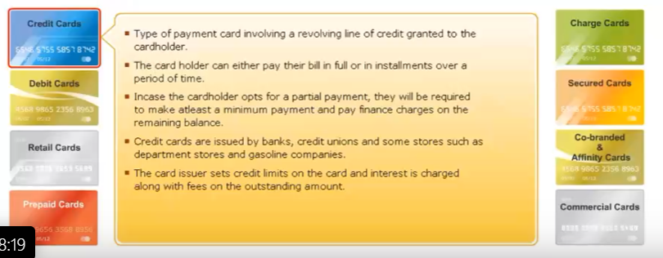

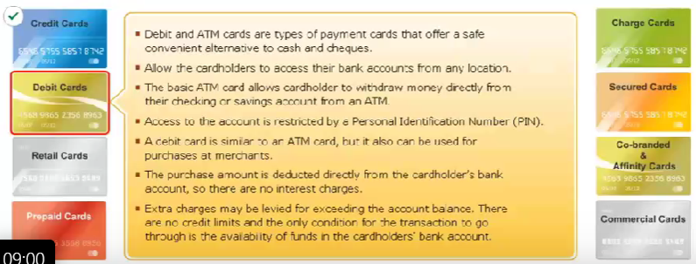

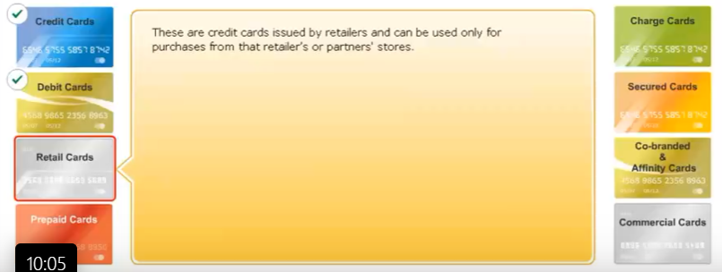

Closed loop cards are branded and issued by merchants and can be used only at those merchants outlet for redemption.

Open loop cards are issued by banks and will be accepted at all merchant outlets that accept cards.

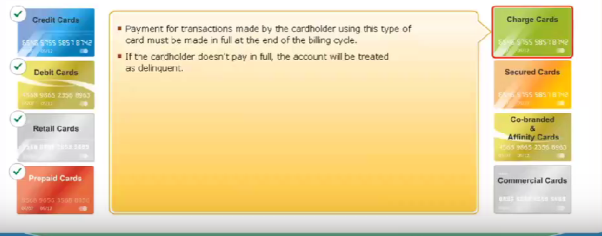

* Diners Club Cards, or Amex corporate cards are typical examples of a charge card.

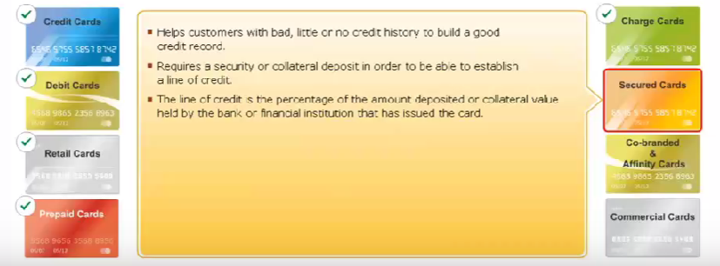

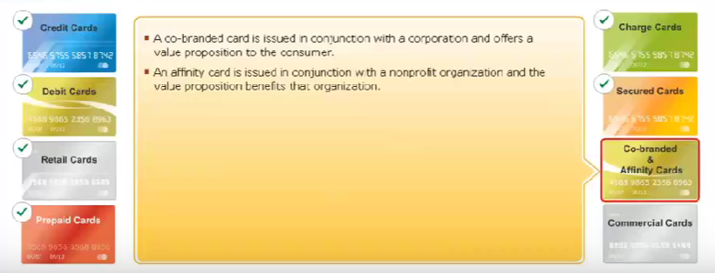

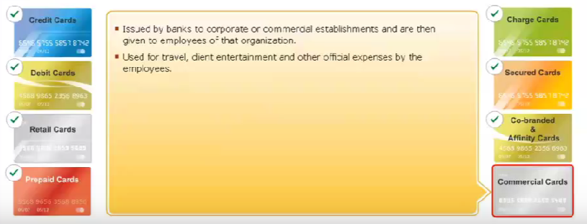

* ISO has established certain standards for maintaining the consistency in the size and the quality of the material used in the making of cards. These standards ensure wide acceptance of the card, international compliance, interoperability between banks, retailers, and card associations both locally and internationally, and helps to reduce fraud.
* 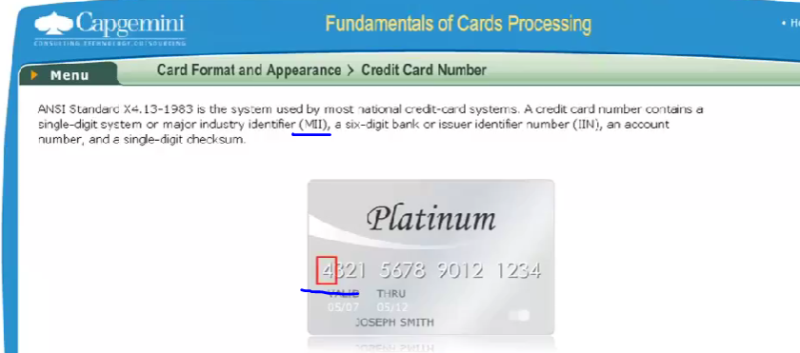
* 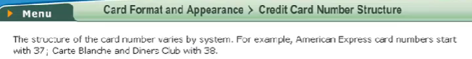
* 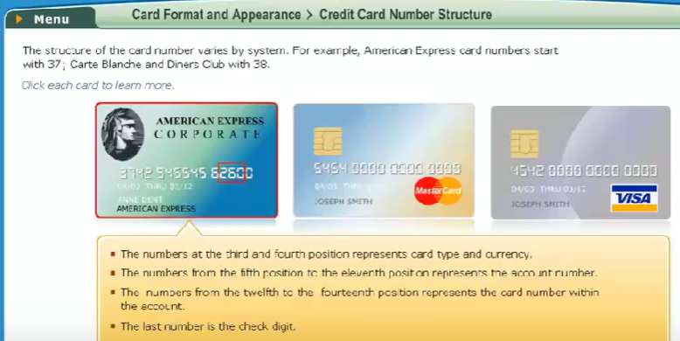
* 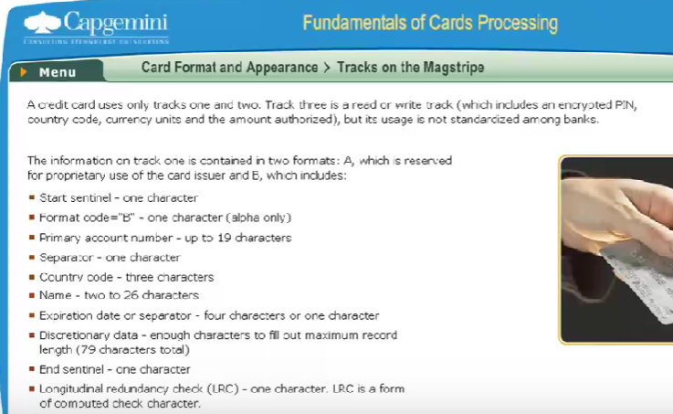
* 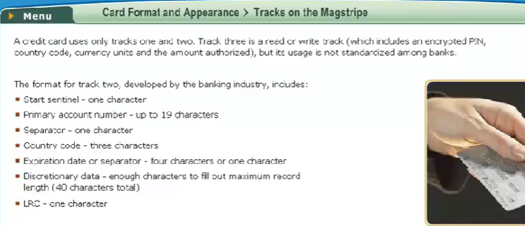
* 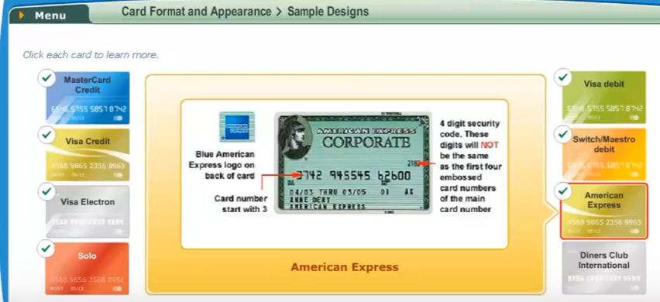
* 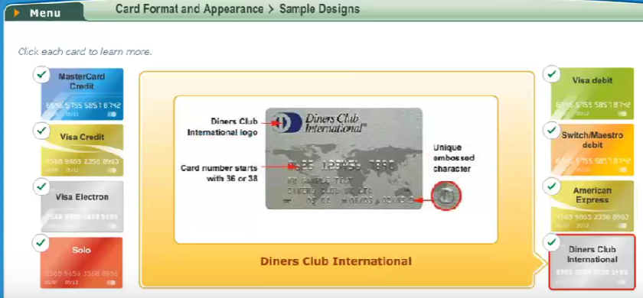
* 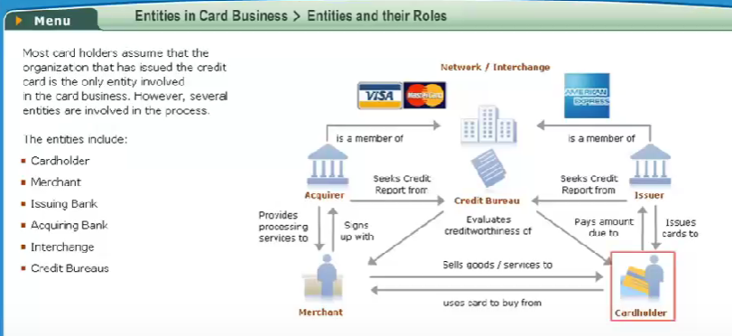
* Card Holder is the end customer in the cards business process who uses his or her card to make purchases or withdraw money.
* Merchant is a business owner who has a device that will accept payments using cards. The device is known as a point of sale POS machine.

In the new age, merchants can be physically present at a location, or could be an Internet merchant. Merchants have tie ups with acquiring bank.

* Issuing bank issues cards to the end customers, which is responsible for generation of the plastic maintaining purchase limits, account maintenance, statement generation, authorizations of transactions, and other related functions.
* Acquiring Bank has the relationship with the merchant. They acquire or take in transactions that the merchants send to them and pass on to the issuing bank through the network. And settle with the merchant. The acquiring bank also rents or sells POS machines to the merchant.
* Interchange or scheme or network are associations that are responsible for routing of transactions between issuers and acquirers, and settlement between the two.

MasterCard, Visa and Amex are some examples of this entity. They perform several key functions, including licensing, setting operating regulations. The most important function, however, is the processing of transactions. They own and operate processing systems that provide capabilities to authorize purchases and settle merchant and cardholder transactions. Before issuing a credit card to an individual customer, banks do a credit check on them.

Similarly, before an acquirer signs a promotion, it doesn't check on the merchant history, it essentially checks the creditworthiness of these entities from a risk and fraud reduction perspective. Organizations which do these checks and maintain databases of credit history of individuals and corporates are called credit bureaus. Equifax, Dun and Bradstreet, Experian and TransUnion are well known credit Bureau.

* 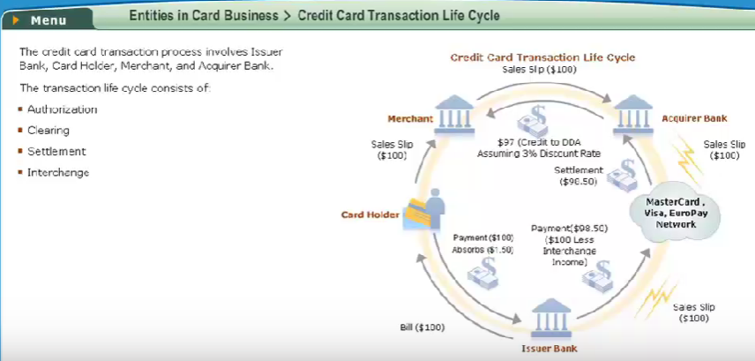
* Authorization is the approval by the card issuing bank, that validates a transaction for a merchant.
* Clearing is the process by which transaction information is passed from acquirer to issuer to post to the cardholder account.
* Settlement is the process by which the amount of cardholder purchases is passed from the acquirers to the issuers.
* Interchange is the critical function managed by the associations. As the word suggests, this function enables the banks around the world to exchange information, transactions, money, and other items under standardize and consistent basis. The interchange flows are shown in the diagram above.
* An important component of the interchange function is the fee. The purpose of the interchange fee is to compensate the issuer, for the free period between settlement or payment, to the acquirer or cardholder purchase and billing to cardholders.
* The fees are set by the associations and may differ by merchant type, Card type and promptness of entry for settlement.

The diagram above reflects a 1.5 percentage interchange rate, or a dollar 1.5 interchange fee on a dollar 100 purchase.

* The fee an acquirer charges to the merchant as compensation for processing and accepting the credit risk on credit card sales is called Merchant Discount. Here the discount rate is assumed to be 3%.
* 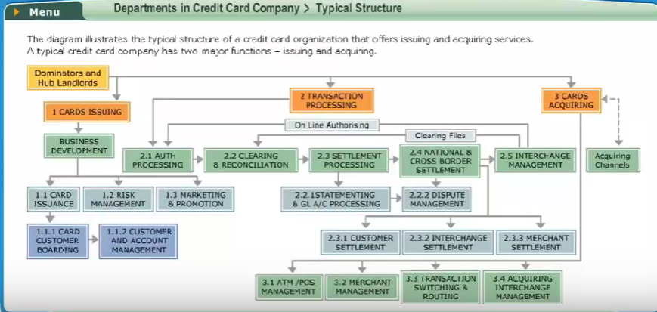

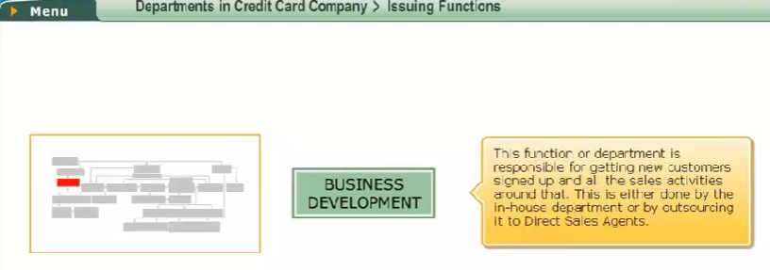

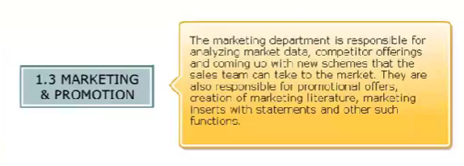 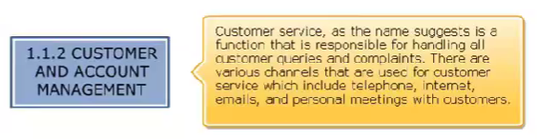

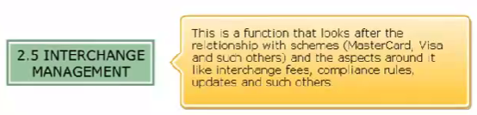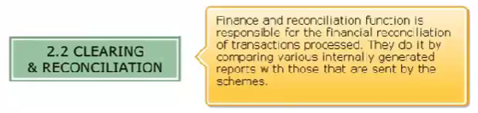

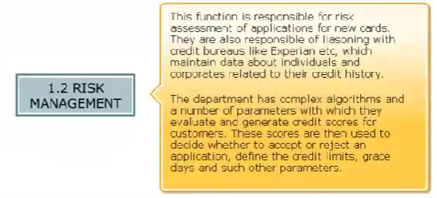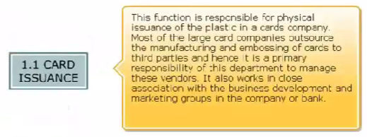

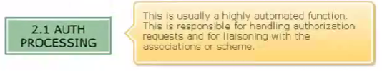

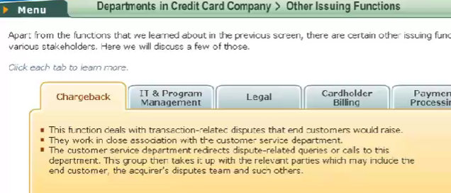

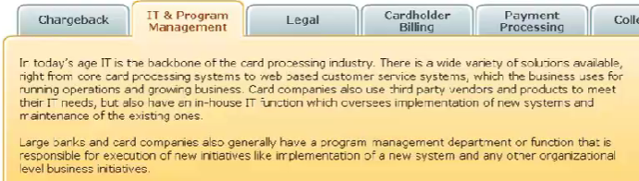

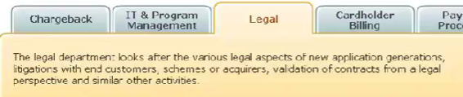

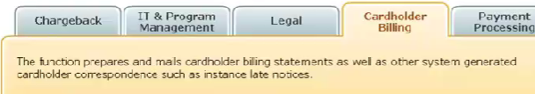

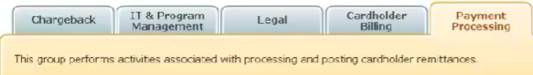

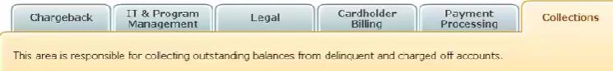

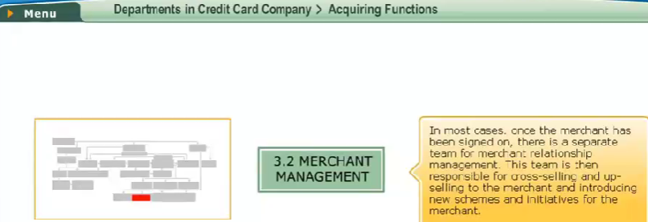

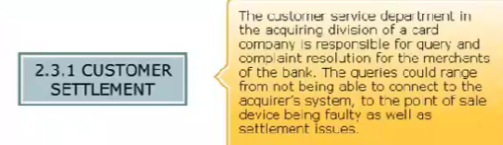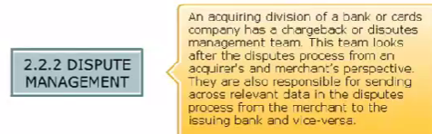

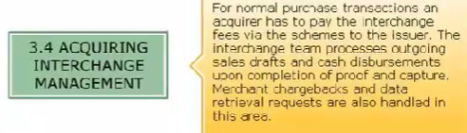

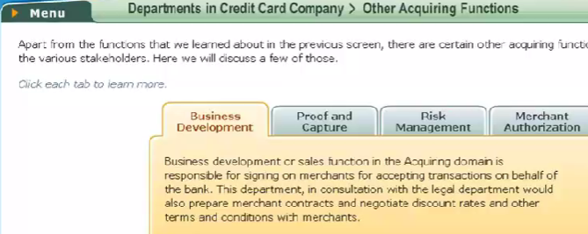

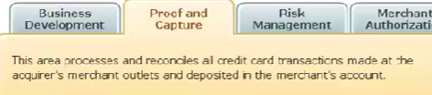

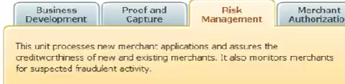

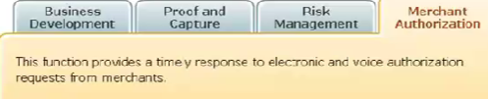

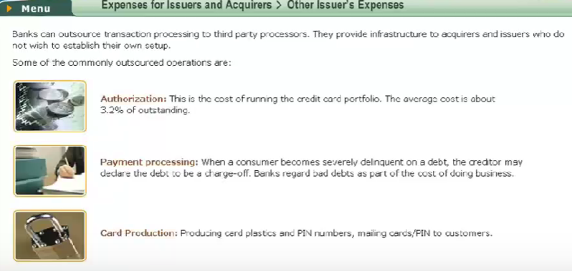

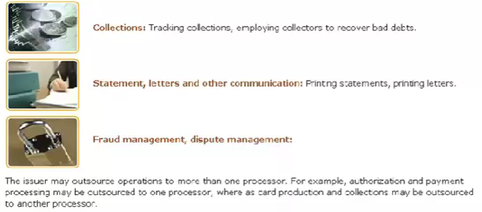

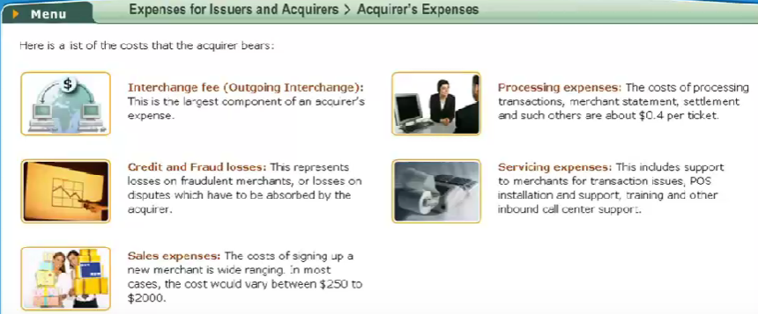

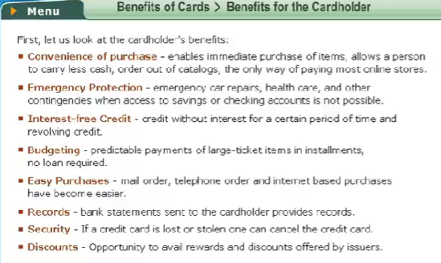

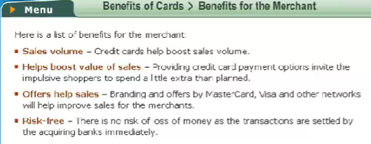

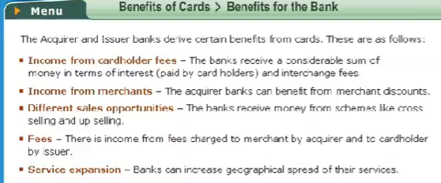

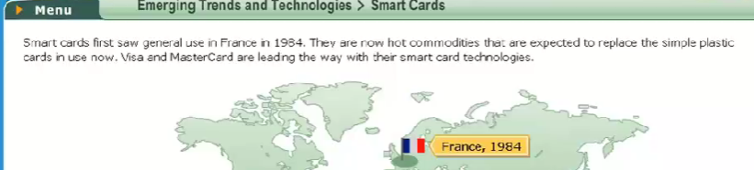

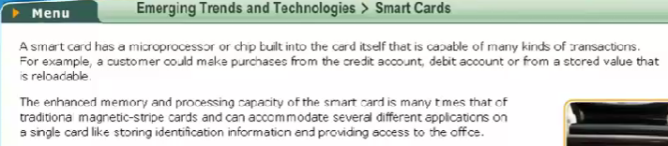

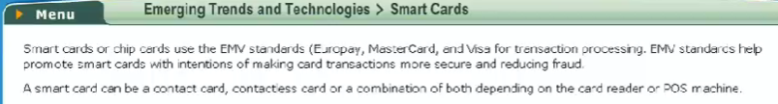

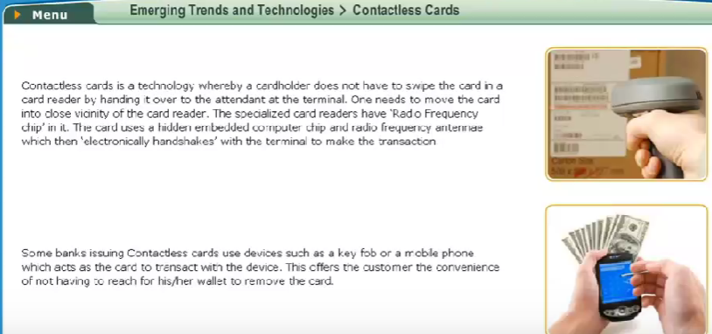

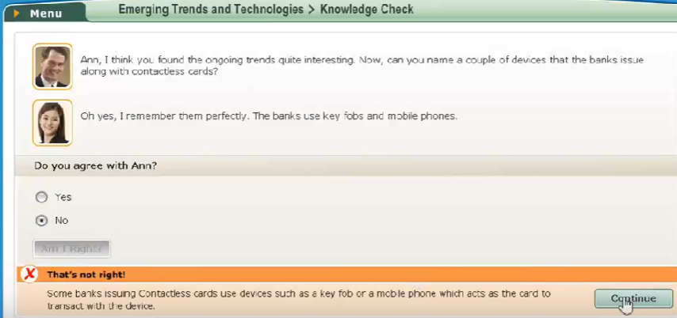

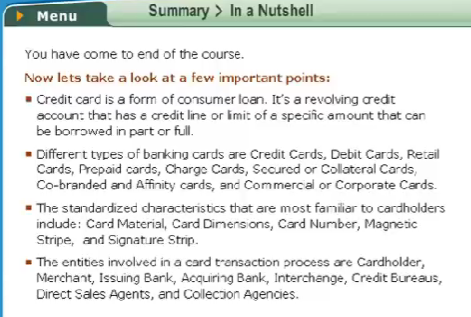

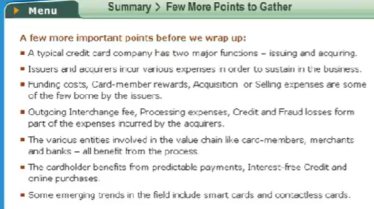

MODULE 2

